CN Lab 10
By Muhammed Owais 23K-0047

Question 1:
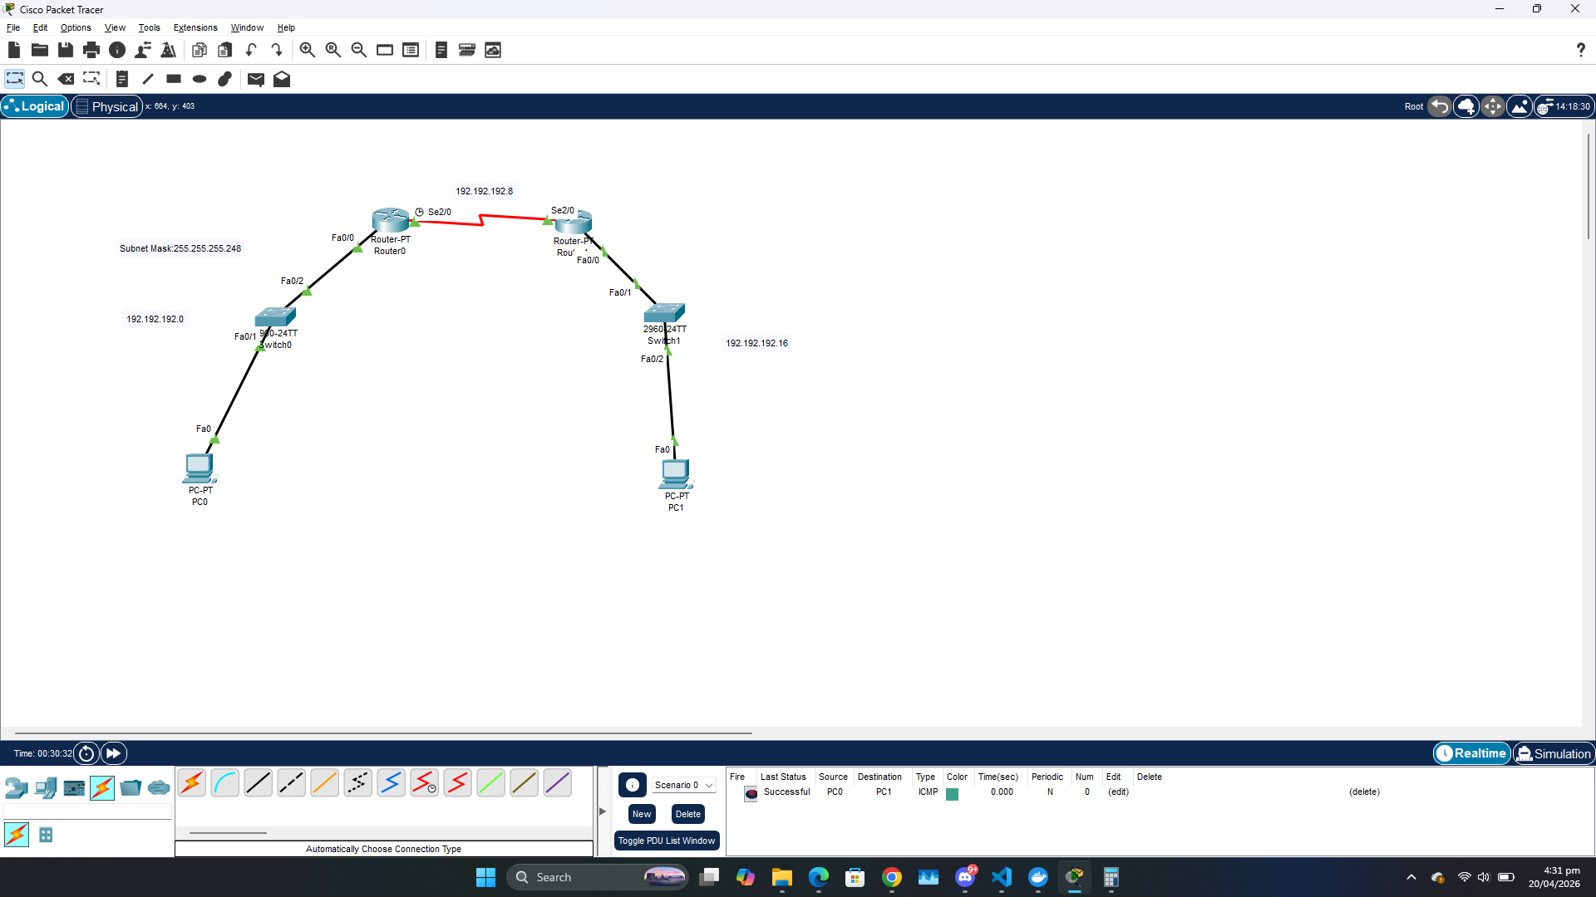
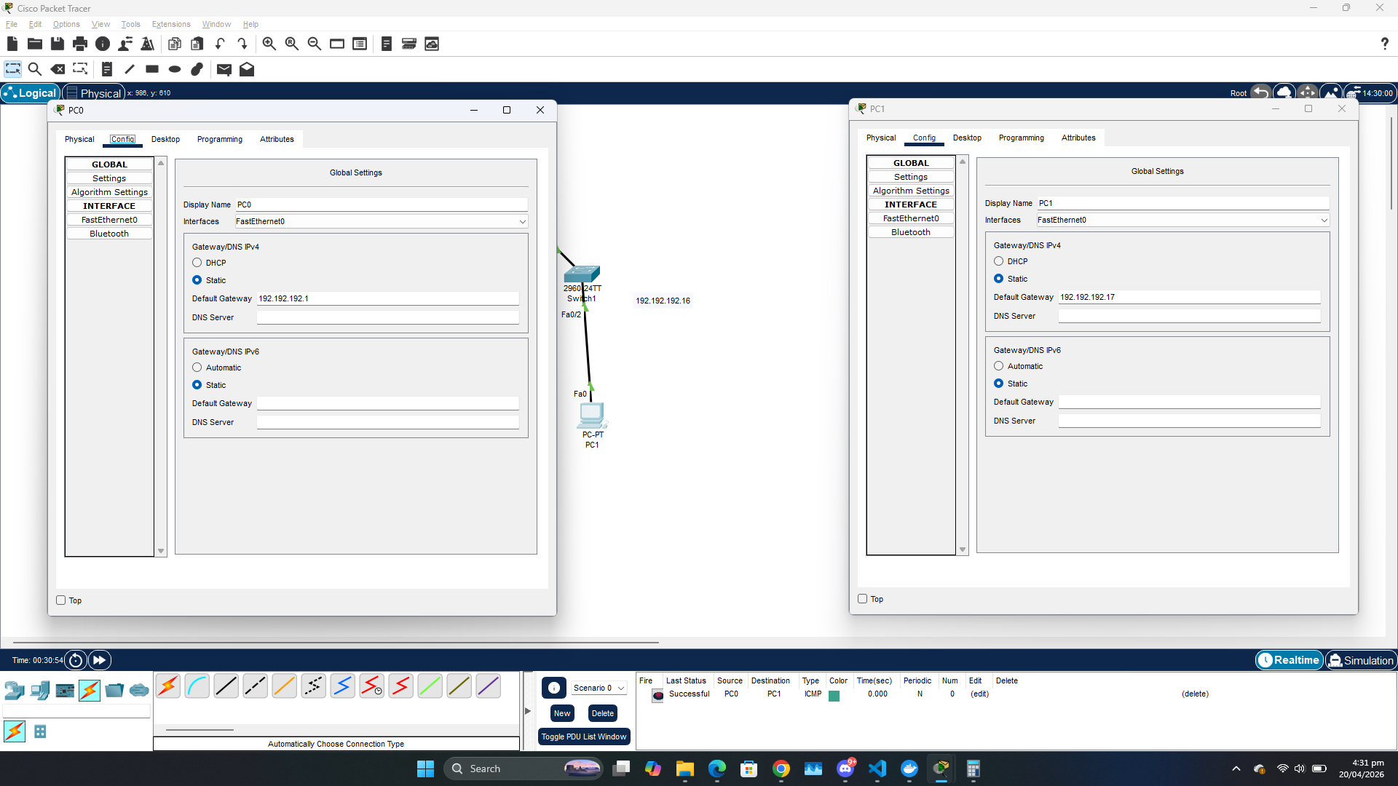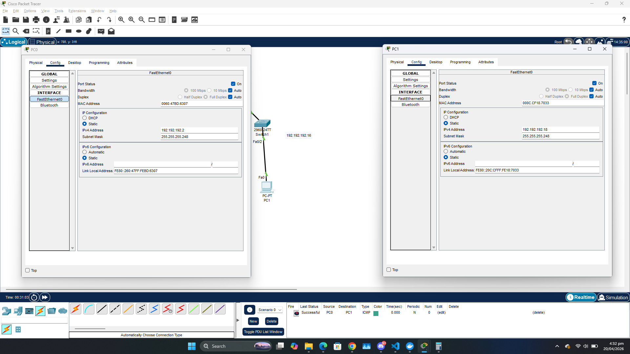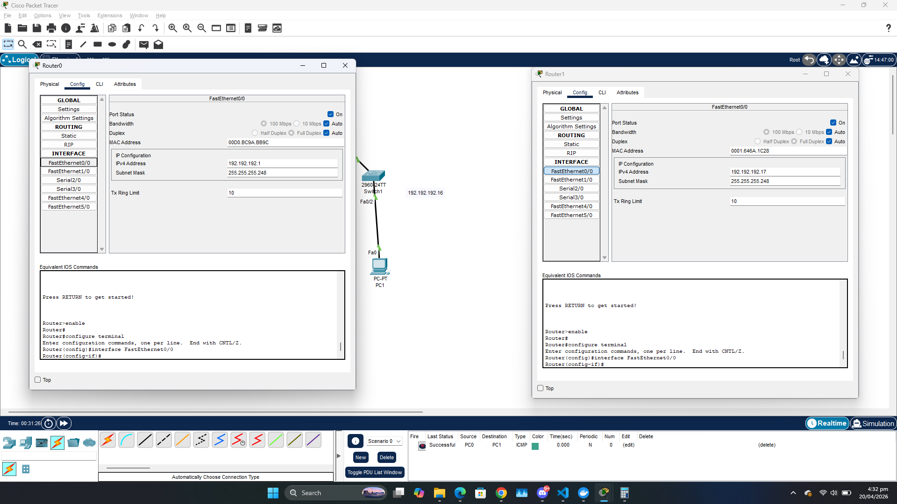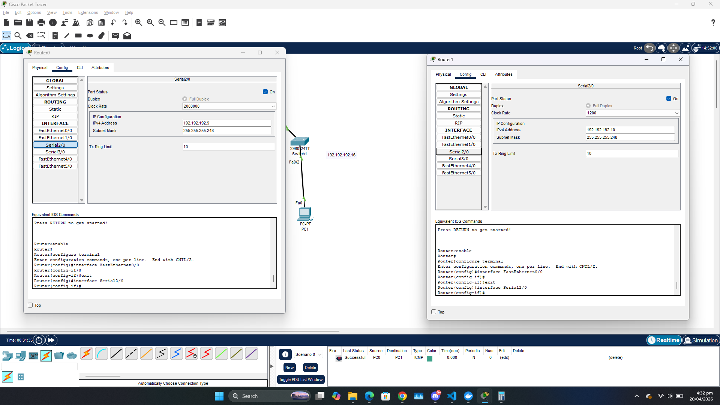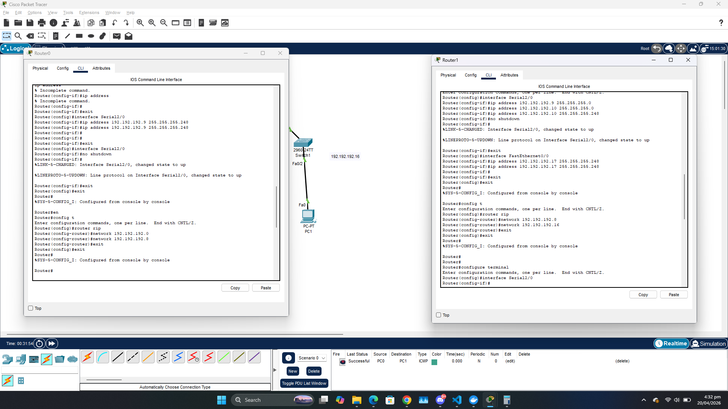

Question 2:
Ans:
Development => 32 Hosts
Finance => 27 Hosts
HR => 10 Hosts

2 Bits => 2^2 = 4 (Networks)

256 / 4 = 64 Max Hosts

2^7 + 2^6 = 192

Subnet Mask: 255.255.255.192

Ranges:
200.16.100.0 - 200.16.100.63
200.16.100.64 - 200.16.100.127
200.16.100.128 - 200.16.100.191
200.16.100.192 - 200.16.100.255

Question 3:
